A.7

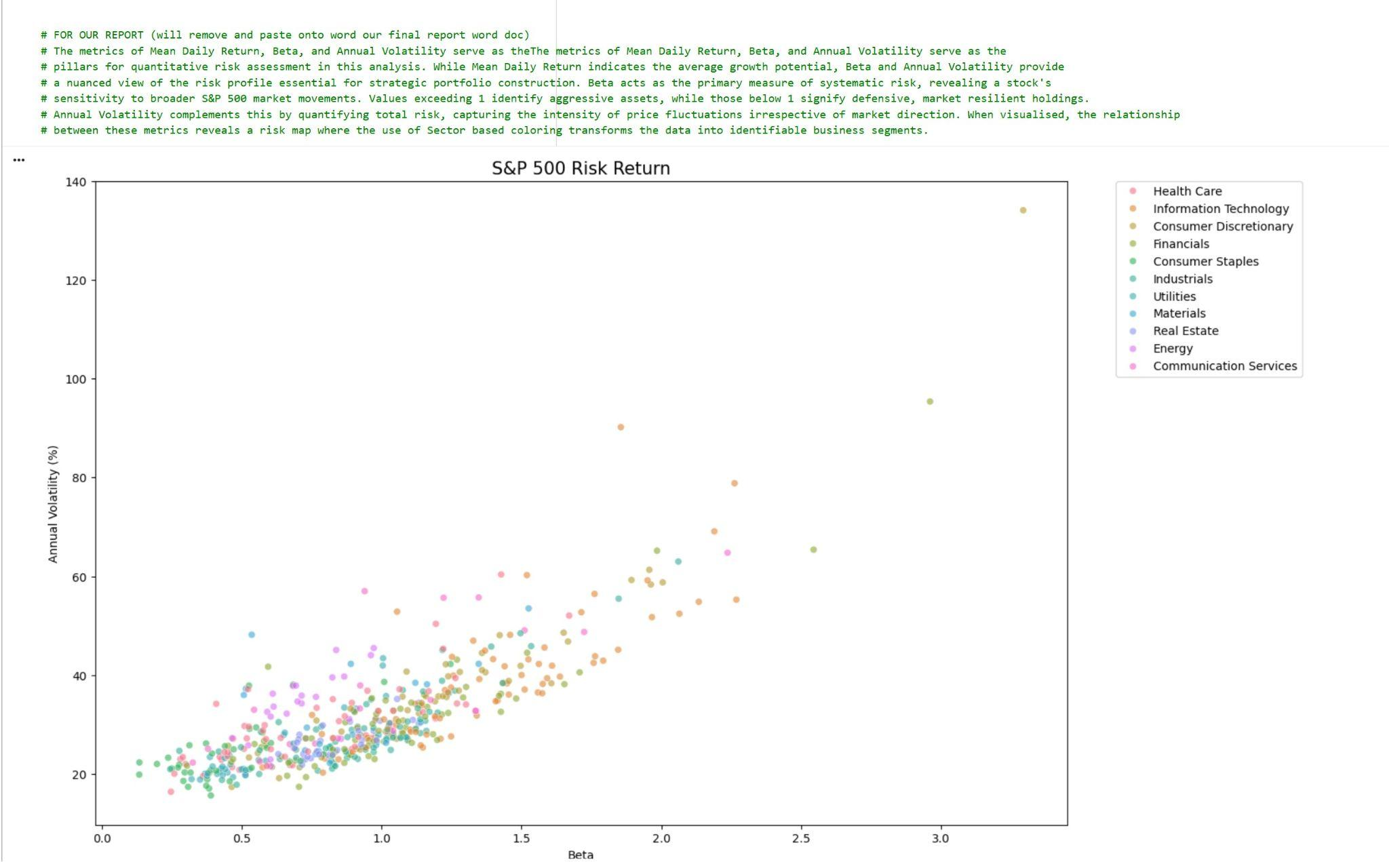
The metrics of Mean Daily Return, Beta, and Annual Volatility serve as theThe metrics of Mean Daily Return, Beta, and Annual Volatility serve as the pillars for quantitative risk assessment in this analysis. While Mean Daily Return indicates the average growth potential, Beta and Annual Volatility provide a nuanced view of the risk profile essential for strategic portfolio construction. Beta acts as the primary measure of systematic risk, revealing a stock's sensitivity to broader S&P 500 market movements. Values exceeding 1 identify aggressive assets, while those below 1 signify defensive, market resilient holdings. Annual Volatility complements this by quantifying total risk, capturing the intensity of price fluctuations irrespective of market direction. When visualised, the relationship between these metrics reveals a risk map where the use of Sector based coloring transforms the data into identifiable business segments.

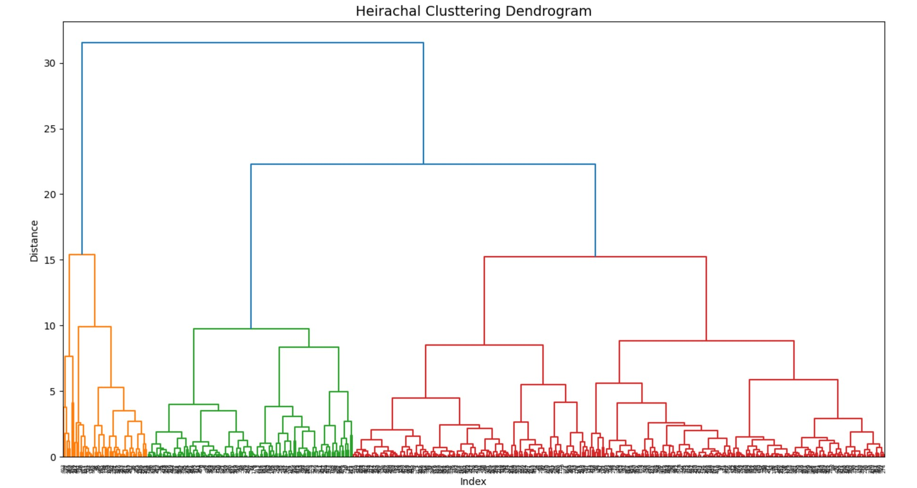
B.1

The Index (X - axis)
Individual stocks

The Distance (Y - axis)
Measures how far apart two stocks are based on their mean return, beata and volatility.

Appropriateness of agglomerative clustering 4 marks:
To perform the initial segmentation of the S&P 500 Agglomerative Hierarchical Clustering was used. This bottom up approach is particularly suitable for financial datasets as it does not require a predefined number of clusters, allowing the natural hierarchy of market sectors to emerge.Using Ward’s Linkage, the model minimises within cluster variance, ensuring that stocks grouped together possess highly similar risk return properties. In order to facilitate this ‘Mean daily return, Beta and Annual volatility’ were processed using the StandardScaler. This ensures that the Beta values are not ignored and treated with equal weight to volatility, despite having vastly different ranges.

B.2

As shown in the Elbow Graph, the inertia decreases sharply until K=3, after which the rate of descent diminishes. This confirms that three clusters represent the optimal balance between minimising within cluster variance and maintaining model interpretability for the S&P 500 dataset.